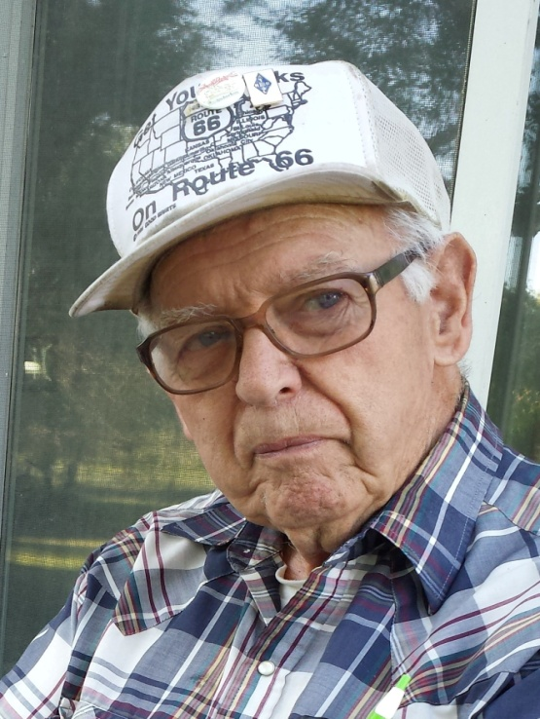
William Melbourne “Bill” Fisher
Uncle Bill Fisher, Monse, WA, passed away suddenly at Providence St. Peter Hospital in Olympia. He was with his long-time loving and adored caregiver, Stacey Marie House his Great-Niece, and other Family members. Recently Uncle Bill had been living at the Beehive Assisted Retirement Community in McCleary, WA.
Uncle Bill was born December 12, 1927 to William Melbourne Fisher and Pearl Ellen Paul in Tacoma, WA. He was quickly joined by his brother Gordon R. “Doug” Fisher and Lyle “Ike” Fisher. When Uncle Bill was only a few years old his Mother Pearl Ellen contracted Tuberculosis and died in childbirth, leaving his Dad William “Mel” with 3 little boys. They were briefly looked after by their Cousin Arlene Morris Joy. Then tragedy struck again and their Father William “Mel” Fisher also passed away. They were cared for then by their Grandmother Gunal Thompsen “Nellie” Fisher in Bremerton, WA. When Uncle Bill was around 11 or 12 he contracted Tuberculosis and was sent to Edge Cliff Sanatorium in Spokane, WA. In the meantime their Grandma Nellie had passed away and his brothers Gordon and Lyle were sent to live with their Fathers sister and her husband, Myrtle and Harley Morris at their Ranch on the Colville Reservation at Cameron Lake. After his internment at Edge Cliff he too was sent to live on the ranch. In Jr/Sr High School his Tuberculosis returned, and was sent to Edge Cliff again where he ended up with a lung removed. It was then he met the girl who would a few years later become his wife, Retha A. Deatharidge from Sunnyside, WA. When Uncle Bill was released from Edge Cliff he came to Okanogan to finish school and lived with Dr. Stevens. After completing high school a year late in 1949, he attended Washington State College (now WSU), all the while, corresponding with his future wife Retha. On May 7th, 1952 he and Aunt Retha were married with his brother Gordon as his best man and her sister Eula as maid of honor. The couple settled in the Omak/Okanogan area where Uncle Bill went to work for Elder Auto Parts and Aunt Retha worked in the office. In 1957, the couple then moved to Quincy where Uncle Bill worked for the local Radio Station as a Technician, and then moved yet again to Mount Vernon to work for another Radio Station. While in Mt. Vernon, Uncle Bill went to work for Bell Telephone as a Technician. They lived in Mount Vernon for several years often taking in nephews and nieces to stay, as they did not have any children of their own. In 1966, Uncle Bill accepted a job in Brewster as a Satellite Technician at ComSat and worked there until his retirement. They made their permanent home in Monse, which Aunt Retha lovingly referred to as “Dog Patch U.S.A”. Uncle Bill and Aunt Retha also at that time became small time farmers, having a small herd of cows, chickens, an alfalfa field, a small orchard, lots of barn cats and their beloved wiener dogs. It was there that they continued to take in their many nieces and nephews still, having them stay weekends, work haying or in some cases living there when necessary. Uncle Bill used to dress up every Christmas as Santa Claus and give out gifts to the little kids at Granny and GrannyPop Morris’s. They loved to go camping and traveled all over the United States, and have the boxes upon boxes of slides to prove it! Uncle Bill was an avid HAM Radio Operator and was active in numerous HAM Operator Clubs. They frequently camped with their HAM Radio friends. He was one of the men that were instrumental in the constructing and maintaining the HAM Radio Tower at Omak Mtn. He was a lover of Classical Music, Bach, Beethoven, Haydn and Chopin being his favorites. They lived the life they wanted and felt very happy to have each other. They loved family and family functions. Uncle Bill loved having coffee as much as possible with the “guys” down in Monse. Both he and Aunt Re adored their great nieces and nephews and always wanted to know what they were doing, about school, sports, work, etc. In 2005, Aunt Retha passed away after a brief illness and then Uncle Bill decided to travel to Arizona and stay during the winter months with his Old Timer HAM Radio friends.
Uncle Bill was preceded in death by his Wife Retha A. Fisher, Father William Melbourne Fisher, Mother Pearl Ellen Paul Fisher, Brother Gordon Fisher, Brother Lyle Fisher, Aunt and Uncle Myrtle and Harley Morris, Brother/Cousin Bud Morris, Brother/Cousin Don Morris, Brother/Cousin Ord Morris, Brother/Cousin Meb Morris, Brother/Cousin Pib Morris, Sister/Cousin Arlene (Merk) Joy, Sister/Cousin Gwen Cowlishaw, Sister/Cousin Violet Figlenski, Sister-in-Law Doris Fisher and Nephew James T. Fisher
He is survived by his loving care-giver great niece Stacey (Joe) House, Sister in Law Nadean Fisher, Sister/Cousin Marjorie (Leonard) Gargett, Sister/Cousin Myrna Featherly, Cousin/Sister in Law Betty Morris, Cousin/Brother in Law Willis Figlenski, Niece Lillie Fisher Savage, Nephew Kenneth (Linda) Fisher, Niece Cyndi (Steve) Rowe, Niece Retha Fisher-Carpenter, Nephew Ron (Christine) Fisher, Nephew Mel Fisher, Niece Brenda (David) Campanella, Niece Shannon Lacey-Ryan, Niece Sherrie Petrock and many more nieces, nephews, cousins, family and friends who will miss him dearly.
As per Uncle Bill’s wishes there will be no formal service, however there will be a Potluck Brunch to celebrate his life on Sunday, July 23rd @ The Okanogan Area Senior Citizen Center, Okanogan, WA, from 10am to 2pm we will be providing a ham, a couple of breakfast casseroles, punch and coffee, please bring a hot dish, salad, side and or dessert and lots of memories to share. This is a non-alcoholic event, no drinking will be tolerated anyone with alcohol will be asked to leave the premise.
Uncle Bill will have his ashes buried alongside his beloved wife Retha in Arkansas at a later date.

